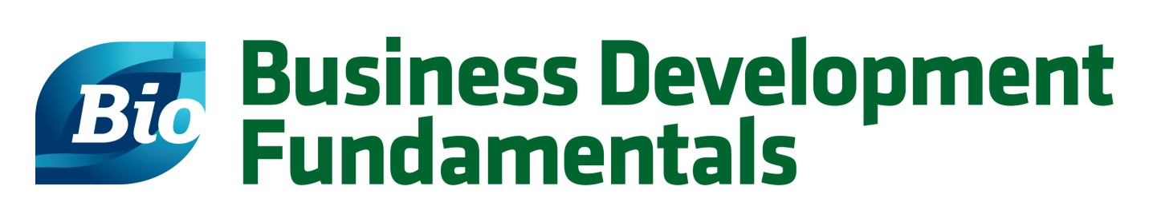

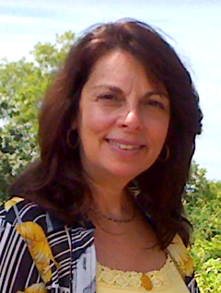
Christine T. Fischette, PhD
CEO, BioLinkUp, LLC
Christine T. Fischette is CEO BioLinkUp, LLC, a Corporate Strategy/Business Development Consulting entity, Senior Advisor at Griffin Securities, Inc., NY, a boutique investment banking firm, and Board member of GCA Therapeutics, a US-based conduit which seeks to in-license Western technology, pharmaceuticals and devices for the China market. She serves on private company Business/Scientific Advisory Boards for therapeutics/devices, is Chair of the M&A Committee for the Licensing Executive Society (LES), Co-Chair for the LES NYC Chapter, an invited reviewer of grant proposals at Rockefeller University to assess future development/commercialization potential, and frequently speaks on BioPharma panels at local/international meetings.
Formerly, she was President of Enzo Therapeutics, Inc., a division of Enzo Biochem (ENZ:NYSE), and has spent 25+ years in Roche, Novartis and Pfizer with increasing areas of responsibility in operational and strategic roles covering multiple therapeutic areas of drug development, commercialization and business development. She functioned as Head of Negotiation, Global Business Development & Licensing for various therapeutic Business Franchise Boards at Novartis Pharmaceuticals where she identified, negotiated and executed multiple deals involving various deal structures, including acquisitions, with US, European, Japanese and Indian companies. She held various positions of increasing responsibility at Pfizer, NY directing preclinical/clinical development, IND’s/NDA’s, medical marketing, marketing and business development. During her tenure at Pfizer she directed the entire drug development process and subsequent marketing effort for an anti-diabetes therapy, Glucotrol XL®, and became head of Pfizer’s US commercial diabetes division.

