

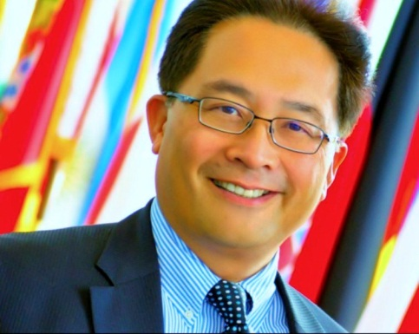
Michael W. Young
Vice President, PAREXEL Clinical Research Services
Michael is Vice President, Business Development at PAREXEL International. He is an accomplished, pharmaceutical and biotech executive with award-winning marketing and commercial operations credentials. He is a sought-after subject matter expert in the discipline of Alliance Management where he has honed his skills as a collaboration manager in a broad spectrum of B2B strategic partnerships and with the Association of Strategic Alliance Professionals (ASAP).
Prior to joining PAREXEL International, he was Vice President; Alliance Management for a different global contract research organization (CRO) During his 4 year tenure, he also innovated and built an external vendor alliance capability for the CRO to dramatically improve client interface and results. Michael previously also pioneered a global Alliance Marketing & Management department and capability for Eisai Inc. Prior to this he spent eleven years as Director of Marketing and then Executive Director, Strategic Marketing, Ligand Pharmaceuticals Inc. His commercial career also includes sales management, marketing, and new product development positions at GSK, Adria Laboratories, and Bayer.
Among his credentials, Michael was named Medical Marketer of the Year by the Medical Marketing Association. Michael serves on the board of directors of the Cutaneous Lymphoma Foundation. Michael received his undergraduate degree from Kenyon College and did his graduate work at The Ohio State University.

